Correct Output 2
Send Feedback

What will be the output of the below given code?
<!DOCTYPE html>
<html>
<head>
<style>
.flex-container {
display: flex;
flex-wrap: wrap-reverse;
background-color: #8ffcc9;
width: 400px;
}
.flex-container>div {
background-color: white;
width: 60px;
margin: 5px;
text-align: center;
line-height: 50px;
font-size: 30px;
}
</style>
</head>
<body>
<div class="flex-container">
<div style="flex-grow: 5;">1</div>
<div style="flex-shrink: 1;">2</div>
<div style="flex-shrink: 2;">3</div>
<div style="flex-shrink: 1;">4</div>
<div style="flex-grow: 5;">5</div>
<div style="flex-grow: 1;">6</div>
<div style="flex-grow: 2;">7</div>
</div>
</body>
</html>

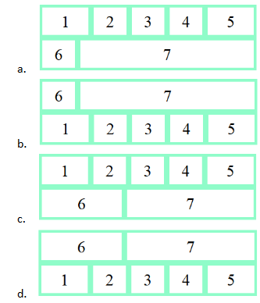

Ans: d

